Web design Proposal

I want the “Just Do IT logo for my web design.

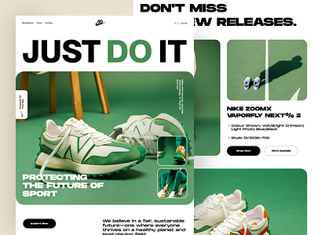

The photos ideas

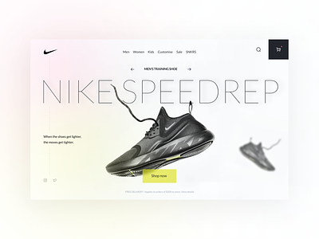

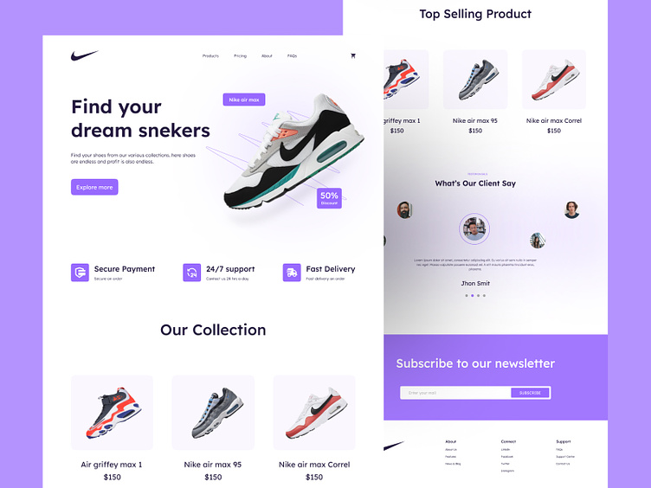

This is my websites planned layout



